Infrastructure as Code
What is Infrastructure as code?
Before understanding what Infrastructure as code is, let’s have a look how the infrastructure was managed traditionally.
Let’s consider a private data center, which has VMware running inside.
Imagine if someone who wants to make some resource or let’s say a server, this was the procedure they had to follow every single time:
- Raise an IT ticket
- Someone from the IT team will process the ticket, sent it to a review team
- And finally, after reviewing from all aspects, operation team will provision that piece of infrastructure.
Now same goes to remove that piece of infrastructure.
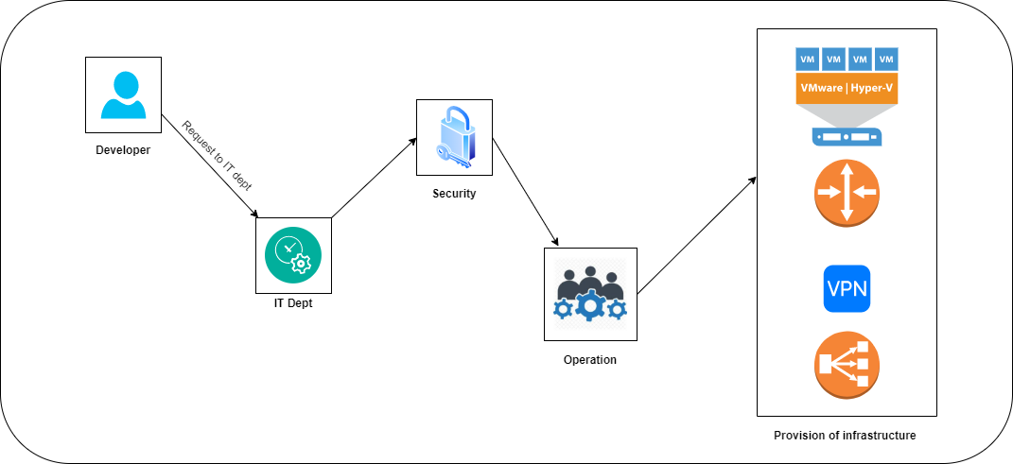
Traditional Approach
This approach was fine as we had very limited piece of infrastructure, the provisioned server used to live for months and years, there was a relatively limited scale of deployments, and since it was a private data center it was working fine.
When did this approach failed?
- One, when industry made a transition on cloud.
- Second, there's a much higher elasticity of infrastructure, where instead of months to years, it's now days to weeks in terms of how long a resource might live.
The scale of infrastructure is much higher in modern approach. Instead of having one large Instance (traditional approach), now we have many smaller instances. We might scale up the load during the peak days and then scale down at night to save our cost (unlike owning a hardware, we are on cloud and we are paying on hourly bases), so we pay for only what we use. So, it’s important to remove the piece of infrastructure immediately when we are not using it.
Similarly, provision the piece of infrastructure as fast as possible based on our needs.
Now imagine raising thousands of tickets to spin up the infrastructure at peak time and file another for spin them back down. Will this not affect your business?
Another major problem was how to manage the vast infrastructure?
Imagine you have made a request to IT team to spin up an infrastructure on cloud which consist of various resources such as multiple VM, Storage, SQL etc.
IT team have successfully reviewed and spin up the infrastructure in a specified environment.
Now, you want the same infrastructure in QA and Prod environment as well, and you raised another ticket for the same, and IT team has successfully reviewed and spin up the infrastructure in QA and prod.
But soon after your application deployment, you noticed your application is not working as expected as it was working in Dev environment, even though the deployment code was exactly the same.
So, what was the problem? After spending hours, you noticed that the problem was in the infrastructure configuration drift, there was a minute change in the infrastructure in Dev and QA and prod by the IT team, a human error (as they manually setup the infrastructure). If they would have spin up the infra exactly with the same configuration as they did for dev environment, the problem would have not occurred.
So, we faced two major problem:
- The ticket raising system
- The configuration drift and management of the vast infrastructure
How do we begin to operationalize this in a way that's reliable and robust, and not prone to human error?
Now, here Infrastructure as code plays its role to solve these two problems. So, the real idea behind infrastructure as code is: How do we take the process—in some sense, the things that we were pointing and clicking to achieve—how do we take that and capture that in a codified way? So, if I need to do it one time, ten times, or a thousand times, I can automate that.
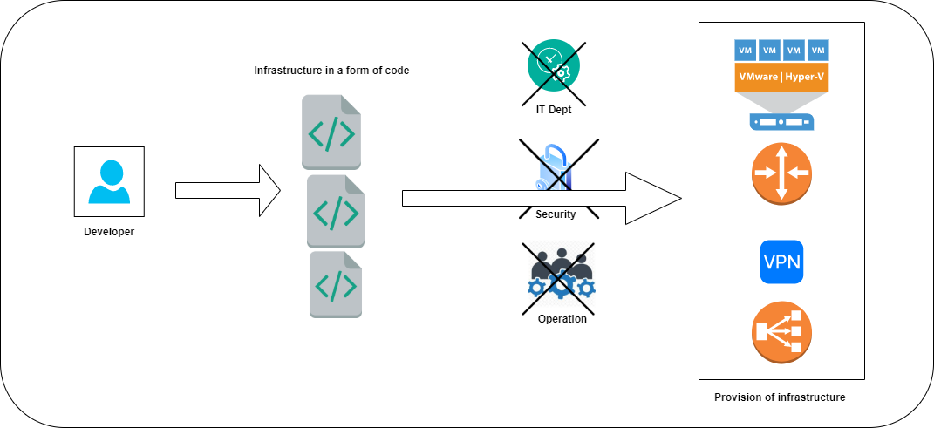
Modern Approach
Every morning, I can hit a script that brings up a thousand machines, and every evening, hit the same script to bring it back down to whatever our evening size is.
I can begin to both automate that, but also now that I've captured it as a codified form, I can check it into version control, and I get versioning. Now I can see an incremental history of who changed what, how is my infrastructure defined at any given point of time, and I have this transparency of documentation that I lack in a traditional point-and-click environment.
The following problem got solve as soon as adopting IaC.
- Infrastructure as Code evolved to solve the problem of environment drift in the release pipeline. Without IaC, teams must maintain the settings of individual deployment environments. As the resources increase over time, it becomes difficult to reproduce the same in all the environment manually. Inconsistency among environments leads to issues during deployments.
- Idempotence is a principle of Infrastructure as Code. Idempotence is the property that a deployment command always sets the target environment into the same configuration, regardless of the environment’s starting state. Idempotency is achieved by either automatically configuring an existing target or by discarding the existing target and recreating a fresh environment.
- IaC automation dramatically speeds the process of provisioning infrastructure for development, testing, and production Because it codifies and documents everything, IaC can even automate provisioning of legacy infrastructure, which might otherwise be governed by time-consuming processes (like pulling a ticket).
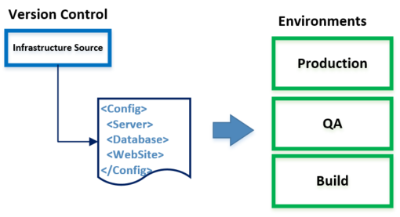
- In addition to dramatically reducing the time, effort, and specialized skill required to provision and scale infrastructure, IaC lets organizations take maximum advantage of cloud computing’s consumption-based cost structure. It also enables developers to spend less time on plumbing and more time developing innovative, mission-critical software solutions.
- Reusability – Can reuse the codified form / scripts in various environment, without creating a new one. In order to spin up the same resource multiple times, can reuse the existing scripts.
So IaC gives all the benefits such as consistency, accelerating, reusability, extensibility, all were the major cause in traditional approach.
Now, let’s define what is infrastructure as code?
This is how Microsoft defines Infrastructure as Code (IaC) - Itis the management of infrastructure (networks, virtual machines, load balancers, and connection topology) in a descriptive model, using the same versioning as DevOps team uses for source code. Like the principle that the same source code generates the same binary, an IaC model generates the same environment every time it is applied. IaC is a key DevOps practice and is used in conjunction with continuous delivery.

What are the tools available for IaC?
- ( R )?ex
- AWS CloudFormation
- Azure Resource Manager
- Google Cloud Deployment Manager
- JUJU
- Otter
- Puppet
- SaltStack
- Vagrant
- Terraform
Terraform is widely used and adopted by some of the leading cloud technologies like Azure, AWS and GCP.
Below diagram explains the flow of IaC considering Terraform as a language for creating Infrastructure.
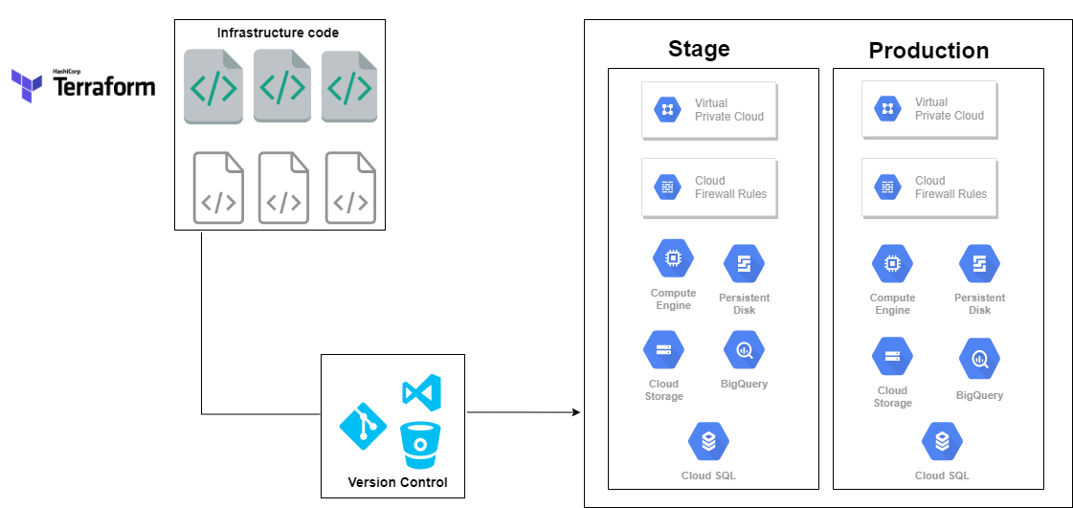

How does the code look like?
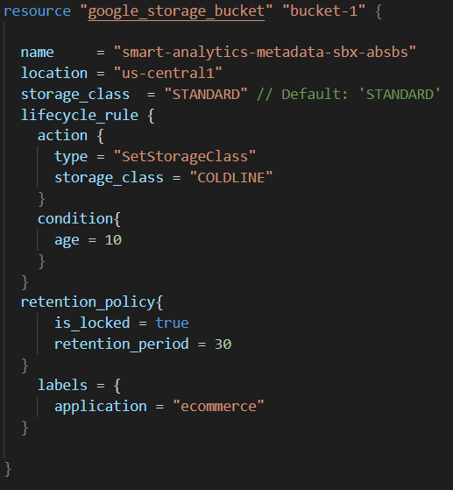
Mentioned about is a sample terraform file which is written in HCL (HashiCorp Configuration Language), which is creating a resource on cloud.
Let’s discuss Terraform in more detail in our upcoming up magazine.

